Dear

Welcome to the next instalment of our West of England Q News…

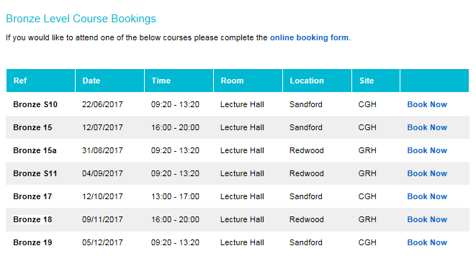

**QI Training for all! Huzzah!**

**Gloucestershire Safety & Quality Improvement Academy** have kindly offered to train all West of England Qs in Quality Improvement. Many of us have already taken part in this training course, so believe us when we say it’s **good**.



* For information please visit <www.gloshospitals.nhs.uk/academy>
* To book your space, please email: [gsqia@glos.nhs.uk](mailto:gsqia@glos.nhs.uk)

**Human Factors of Error – Training opportunity**

Our fellow Q, Lynn Garland, at UHB Simulation Centre, delivers this fantastic course - Patient Safety, human factors and investigation techniques. Please see flyer attached for further info…

**Q Interests**

Speaking of the Human Factors of Errors training, here is Nicola Henderson, from [Palladium Patient Safety](http://www.palladiumpatientsafety.co.uk/Home.aspx) (collaborators on the Human Factors of Error course) In response to the last Q News email, Nicola sent us her interests.

|  |  |  |
| --- | --- | --- |
| **Nicola**  Henderson    [**nicky@palladiumpatientsafety.co.uk**](mailto:nicky@palladiumpatientsafety.co.uk) | | 12 Nicola Henderson |
| **Role**  Independent Patient Safety Consultant | **Organisation**  Palladium Patient Safety |  |
|  |  |  |

"Supporting teams in implementing change for projects they have deemed a priority.  Primarily familiar with using the model for improvement approach for driver diagrams, small scale tests of change, data capture and review, spreading change from one site to another and monitoring to ensure sustained change.  Projects: culture surveys, mortality reviews, improvement programmes for general wards, peri-operative care, critical care and medication safety."**We’d like more of these fantastic snippets of interest so please send me yours!**

**Videos**

As you may recall from the last Q News email, we asked you for your videos. Sally Ashton from 2gether NHS Trust sent us a couple of links. Click on the video below and it’ll take you to one of their newest creations – Who We Are…  Thanks Sally! And for a giggle, we were sent a great QI video by our colleagues in Dorset - “Reach for the charts” – improving medicines management. Go on, click on the image to see the quality improvement work happening in the South West…

[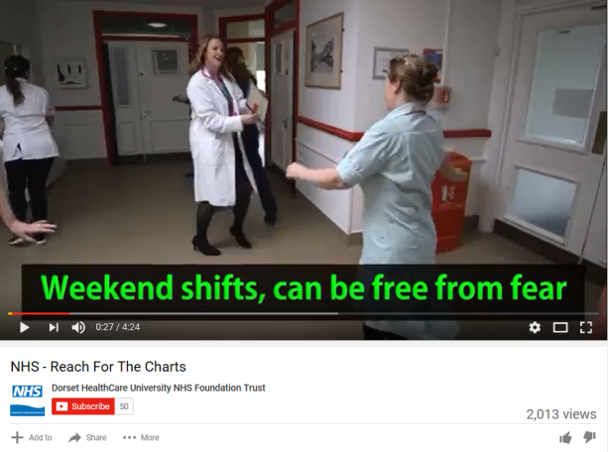](https://www.youtube.com/watch?v=OZZS-DC2Hsk&feature=youtu.be)[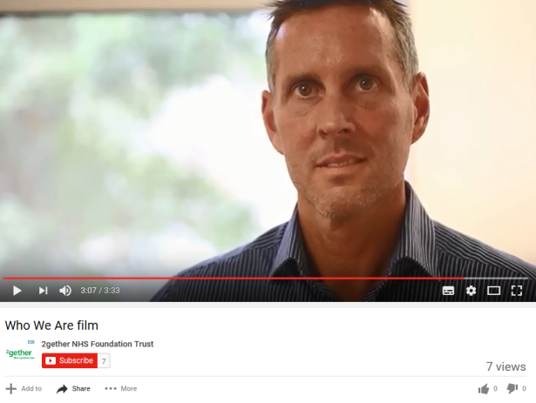](https://youtu.be/m3QS4BHUTl4)

**We’d like to see more of these visual wonders! Send us any videos that you’ve worked on.**

**Twitter Hour – How Do We Q’mmunicate?**

Join us for our second Twitter Hour on the **6 June**, **8-9pm.** We will be discussing how we, the Q Community, connect and network with each other. We all like a good chin wag, so come along and share your ideas. Everyone is invited so even if you wanted the dog to have a say, that’s alright. We’re all about inclusivity here! In all seriousness, this is a really good opportunity to spread the word of Q and provide the opportunity for all Tweeters to have their say. They may even be inspired to apply to be a Q next year. **#WEQs**

**To see our very first Twitter Hour click** [**here**](https://storify.com/WEAHSN/q-mmunity-twitter-hour-weqs)

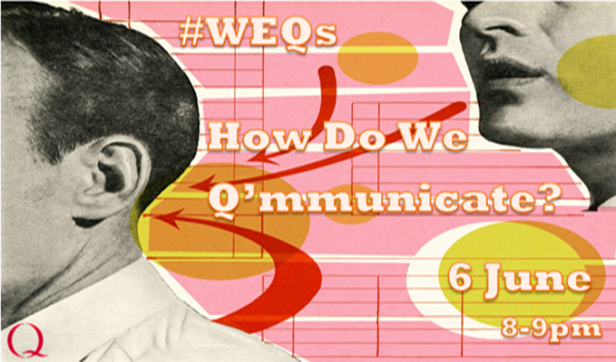

**Case Studies**

Here in the West of England, we’re proud of our QI work and we’d like to share this with you! [Here’s a link to Atlas](http://atlas.ahsnnetwork.com/AHSN/west-of-england/) (found on the AHSN Network site) to see a range of fantastic projects that the West of England AHSN has worked on.

As always, the updated contacts booklet is attached – Version 4. For any alterations, please let me know.

**Important Dates:**

**6 June –** Twitter Hour round 2

**16 June –** Achieving Better Care: Sharing Quality Improvement Strategies – QI Conference in Taunton

**30 June –** Improvement Coach Refresher (for those of you who have trained to be an Improvement Coach and would like a refresher course)[**Register here**](https://www.eventbrite.co.uk/e/refresher-for-improvement-coaches-tickets-34237695870)

**4 and 5 July –** Improvement Coach Programme (for those of you who have not yet trained to be an Improvement Coach) - **FULL**

**13 July –** The Habits of an Improver with Bill Lucas [**Register here**](https://www.eventbrite.co.uk/e/habits-of-an-improver-with-bill-lucas-tickets-34231087103)

**Ta ta for now!**