- Open the video you wish to play.
- Select the subtitles/closed captions feature

- A line will appear under the icon when it has been selected
- Select the settings icon
- Select the language option
- YouTube will provide a list of available languages for this video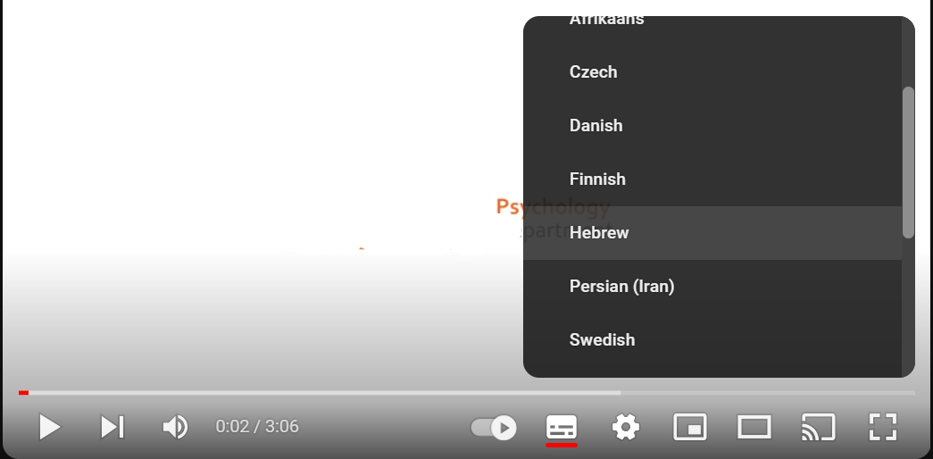

- You can also set it to ‘auto-translate’ which will default to your browser language.

