Communications plan for the PERIPrem project
Background to PERIPrem
The PERIPrem (Perinatal Excellence to Reduce Injury in Premature Birth) project aims improve the outcomes for premature babies across the region through the implementation of a new neonatal care bundle. PERIPrem was co-produced by Health Innovation West of England and Health Innovation South West, and the South West Neonatal Operational Delivery Network.
Read our case study for more information.
Our recommended resource to support communications planning https://www.health.org.uk/publications/communications-in-health-care-improvement-a-toolkit
The bundle consists of a number of interventions that demonstrate a significant impact on brain injury and mortality rates amongst babies born prematurely.
PERIPrem was developed in collaboration between University Hospitals Bristol NHS Foundation Trust (UHB) and Great Western Hospitals NHS Foundation Trust (GWH), led by Professor Karen Luyt and Consultant Paediatrician & Neonatologist Sarah Bates. Karen and Sarah continue to act as clinical leads for the project.
The bundle is the first of its kind, and builds on lessons learned from designing and delivering the PReCePT (Preventing Cerebral Palsy in PreTerm Labour) project as well as being clinically owned and driven by perinatal staff across the region. Regional and national examples of best practice and innovation as well as collaborative working with key partners such as the South West ODN informed the design and delivery of the bundle. It supports maternity and neonatal units in implementing or improving innovative elements of care that will contribute to a reduction in brain injury and death in the smallest and earliest born babies.
A further aim of PERIPrem is to facilitate the perinatal working dynamic at unit and regional level. The project has brought together neonatologists, obstetricians, midwives and neonatal nursing staff to redesign the way in which preterm babies are cared for, ante and postnatally. Quality improvement methodology will embed innovation and creativity into the design process to facilitate effective ways of working that can be shared nationally.
Communications objectives
Target audiences
- Delivery community
- Regional stakeholders
- National stakeholders
- Mothers-to-be – in preterm labour
Key messages
Primary Messages
Supporting Messages
Reaching our target audiences

Audience | What do we want the audience to do?  What is their role in making the programme a success? | Responsibility | Channels

Regional stakeholders

Communications channels
- Direct contact
- Website and toolkit resources
- Newsletter
- Project social media
- Webinars and films
- Patient and clinician stories
- Posters
- Teleconferences
- Face-to-face events
- Awards

Brand identity
Font
Colours
Bundle Icons
In addition to the main logo, each of the bundle elements has an individual icon

PERIPrem logo on background | Thermoregulation
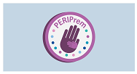 | 
Caffeine | Place of birth
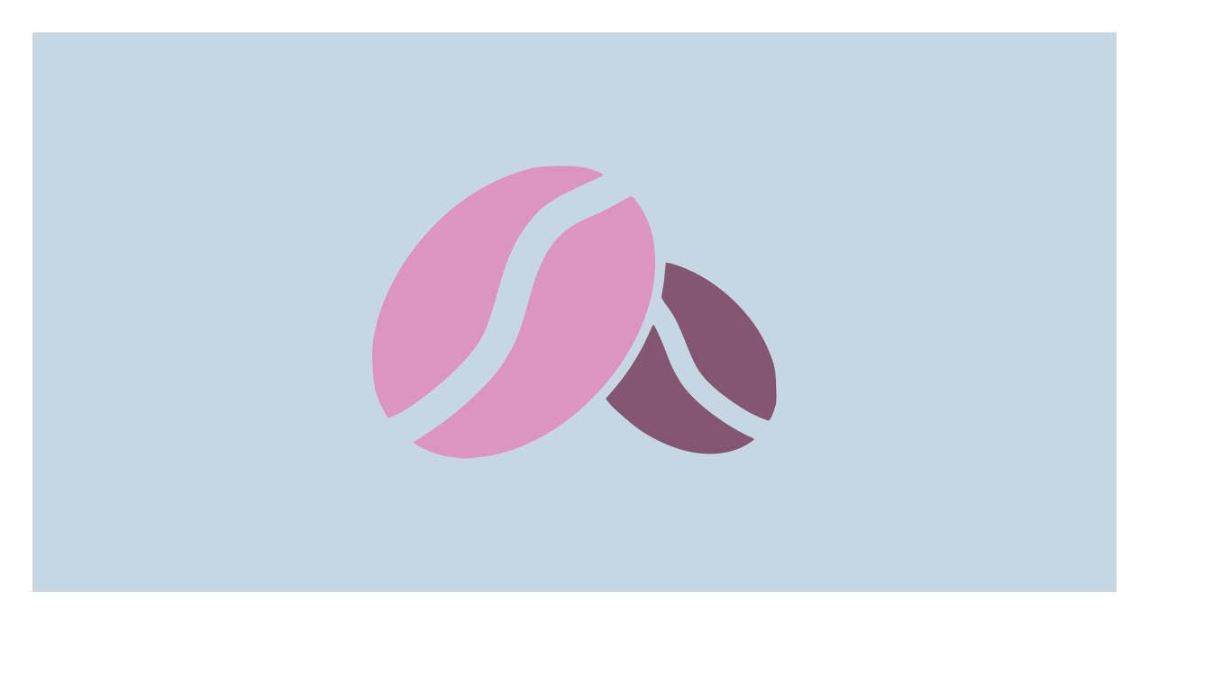 | 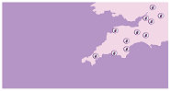
Prophylactic hydrocortisone | Optimal Cord Management
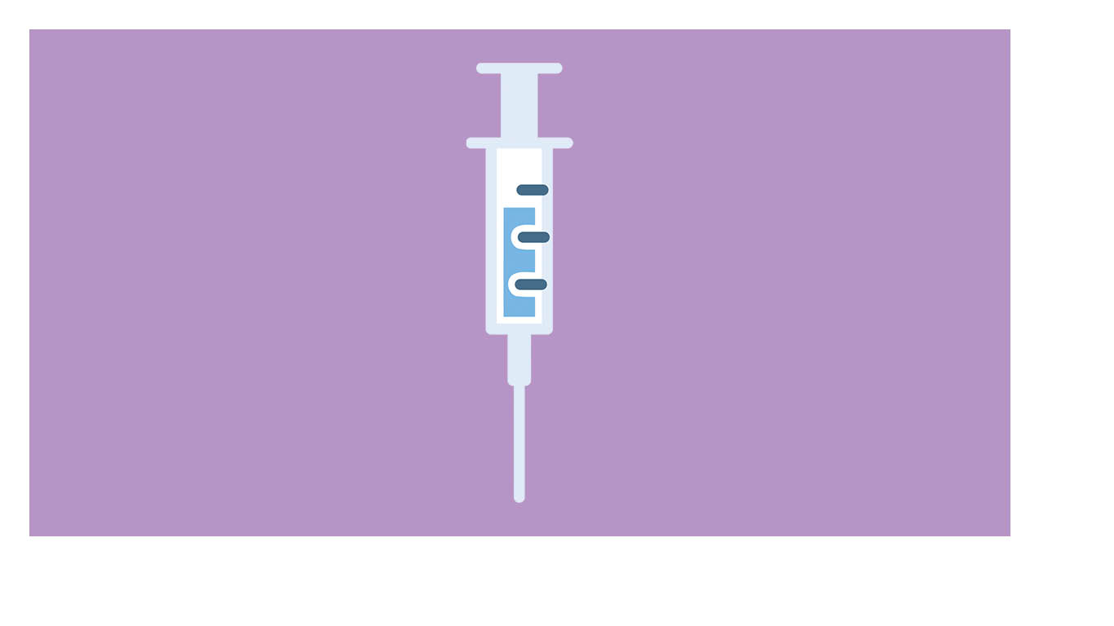 | 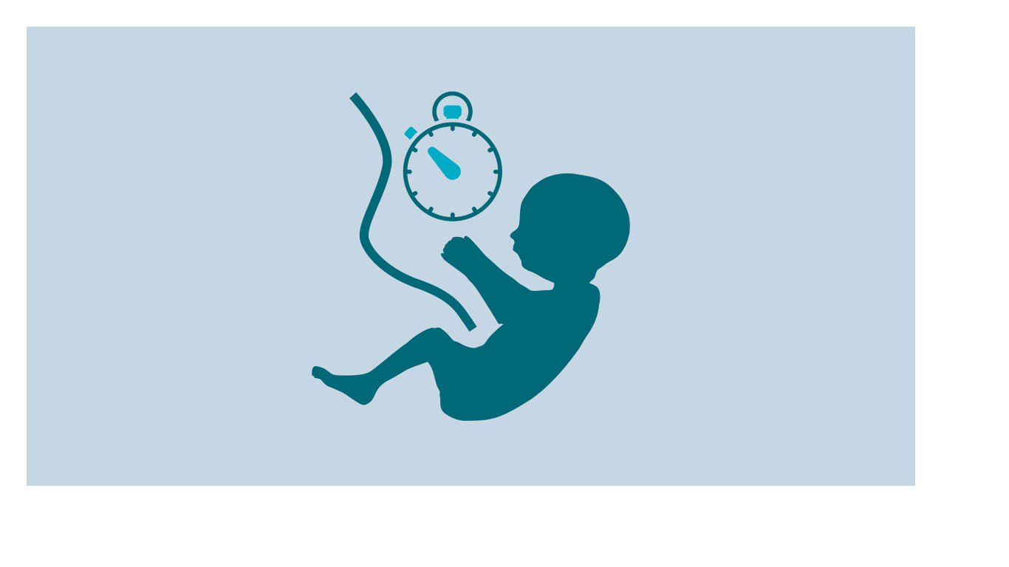
Probiotics | Magnesium Sulphate
 | 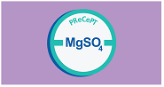
Volume targeted ventilation | Maternal Early breast milk
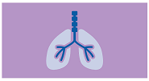 | 
Antenatal steroids | Intrapartum Antibiotic Prophylaxis
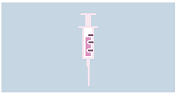 | 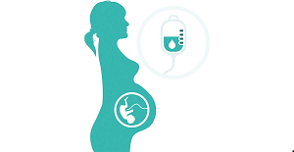

Communications timetable

Dates | Event | Comms Support/activity

Evaluation of communication activity

Objective | Output metrics | Outtake metrics | Outcome metrics

