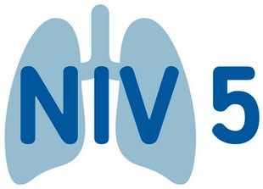
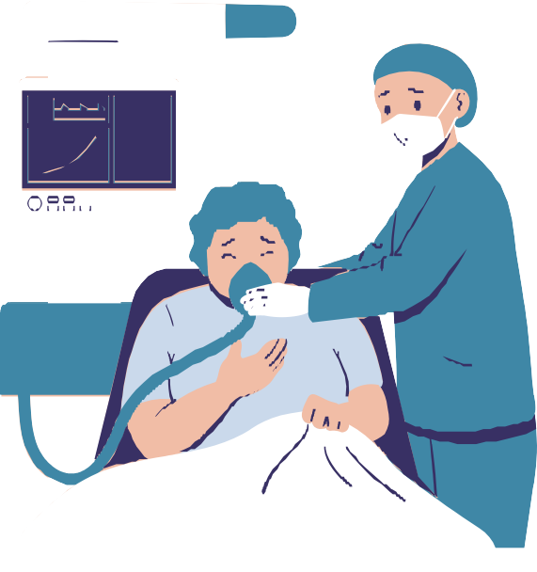care bundle elements

Do you have a patient that may require Non Invasive Ventilation (NIV)?
Have you completed the NIV 5 care bundle?
- NIV is only recommended in acute Type 2 Respiratory Failure where it is proven to be effective:

COPD
Obesity hypoventilation Congestive cardiac failure Kyphoscoliosis Neuromuscular disease Obstructive sleep apnoea

- A Treatment Escalation Plan in place – ReSPECT form is to be completed with specific reference to suitability for invasive ventilation or NIV as ceiling of treatment.

- NIV is to be started within 60 minutes of decision to treat
Once acidosis develops it can worsen
rapidly: prolonged acidosis is associated with higher mortality.

- Inspiratory pressure of 20cmH₂O is to be achieved within 60 minutes unless appropriate exclusion criteria met:
Patient comfort Low BMI
The patient has made a rapid
recovery
If 20cmH₂O is not achieved, ensure the reason is documented clearly in the bundle.

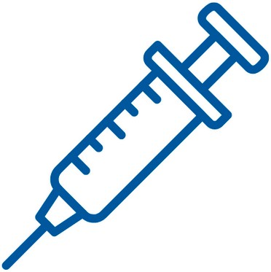
- Arterial or capillary blood gas to be repeated within two hours of starting NIV
This helps to guide ongoing treatment
decisions including changes to ventilator settings.

Contact your local Improving NIV care clinical lead at
To find out more about the improving NIV care project visit www.weahsn.net/niv

